**Out of Class 10-1 Problems**

1. Create the CUSTOMER table structure show below. The customer number should store integer values. The name attributes should support variable length character data up to 30 characters each. The customer balance should support up to six digits on the left of the decimal place and two digits to the right of the decimal place.

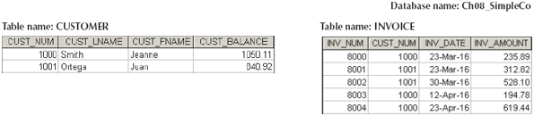

1. Create the INVOICE table structure illustrated above. The invoice number should store integer values. The invoice date should store date values. The invoice amount should support up to 8 digits to the left of the decimal place and two digits to the right of the decimal place.
2. Write the set of SQL commands necessary to insert the data into the CUSTOMER table you created in problem 1.
3. Write the set of SQL commands necessary to insert the data into the INVOICE table you created in problem 2.
4. Modify the CUSTOMER table to include the customer’s date of birth (CUST_DOB), which should store date data
5. Modify customer 1000 to indicate the date of birth on March 15, 1989.
6. Modify customer 1001 to indicate the date of birth on December 22, 1988.